W-16
YEAR 9 SCIENCE
BIOLOGICAL SCIENCES
REVISION - BODY SYSTEMS

Respiratory System

1. What is the difference between breathing and respiration?

2. (a) Explain how respiration is an example of chemical oxidation.

(b) Write a word equation for respiration.

3. Why do cells need oxygen?

4. Why is the blood system so important when considering respiration?

5. Why does an active person need more oxygen than a resting person?

7. Explain the mechanism involved in a human breathing.
i.e. Describe what happens in the body to get air into the lungs and out.

8. Label the following diagram.

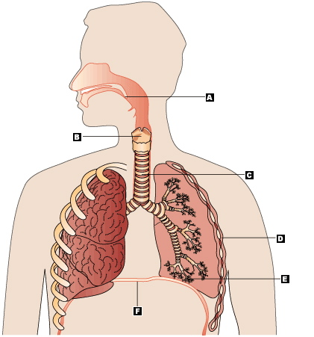

Circulatory System

1. Draw a simple labelled diagram to show the blood flow through the heart and around the body. Include the following.

(a) The arteries and veins, including their names.
(b) The thick and thin side of the heart.
(c) Oxygenated and de-oxygenated blood.
(d) Lungs and body.

2. Give the function of the following parts of the circulatory system.

(a) heart

(b) plasma

(c) red blood cells

(d) white blood cells

(e) arteries

(f) veins

(g) platelets

3. (a) What is haemoglobin?

(b) Why is it so important?

4. Label the following diagram.

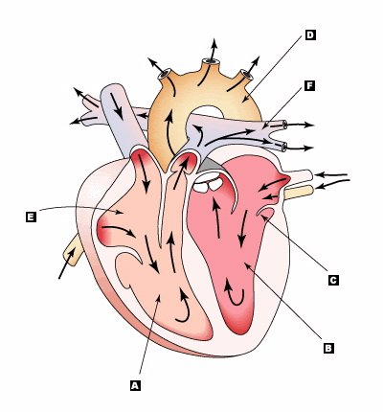

5. (a) What is the role of the valves in the heart?

(b) What is the role of the valves in veins?

(c) Give two ways in which veins are different to arteries.

6. Describe how oxygen (and carbon dioxide) diffuses across the membrane between the alveoli and the bloodstream.

7. What advantage is there in having the alveoli so small, and about 300 million of them in a human's lung?

8. Why does your heart beat faster when you start to run?

Digestive System

1. (a) What is digestion?

(b) Why does food need to be digested?

(c) What is mechanical digestion and chemical digestion?

2. (a) Explain why organisms need food.

(b) Describe how the digestion of a piece of food containing starch takes place from the mouth to the bloodstream.

3. (a) What are enzymes?

(b) Name the three enzymes in the digestive system and name the foods they target.

4. (a) Label the following diagram of the digestive system.

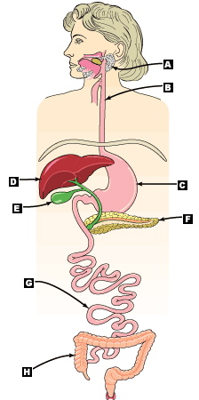

(b) Describe the function of the various parts of the digestive system - consider only the major function. Put them on the diagram above.

5. (a) What are the major nutrient groups?
(b) Describe the major function of these groups.

6. Distinguish between digestion, absorption and elimination.

7. (a) You can show signs of malnutrition by eating too much as well as too little food. Explain how this is possible.

(b) What is meant by a "balanced diet"?

(c) How does the following diagram relate to having a "balanced diet"?

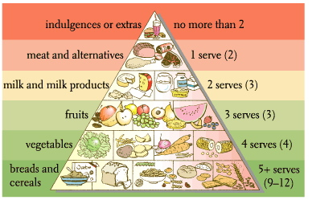

9. What is the role of the villi?

Excretory System

1. What is the difference between excretion and elimination?

2. Label the following diagram of the excretory system and indicate the function of each part.

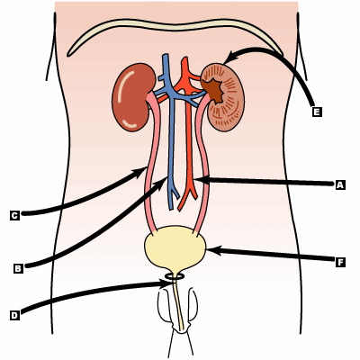

3. Draw a simple diagram of the kidney, label the parts, and describe their function.

4. What are the waste products of excretion?

5. Name the organs responsible for removing wastes from the human body, and indicate which wastes each removes.

6. Everyone knows that faeces is a waste! Right or wrong? Explain.

